**Module-7) React - Applying Redux**

1. What is Redux?

* Redux is an open-source JavaScript library used to manage application state. React uses Redux for building the user interface. It was first introduced by **Dan Abramov** and **Andrew Clark** in **2015**.
* React Redux is the official React binding for Redux. It allows React components to read data from a Redux Store, and dispatch **Actions** to the **Store** to update data. Redux helps apps to scale by providing a sensible way to manage state through a unidirectional data flow model. React Redux is conceptually simple. It subscribes to the Redux store, checks to see if the data which your component wants have changed, and re-renders your component.

1. What is Redux Thunk used for?

* Redux Thunk middleware allows you to write action creators that return a function instead of an action. The thunk can be used to delay the dispatch of an action, or to dispatch only if a certain condition is met. The inner function receives the store methods dispatch and getState as parameters.

1. What is Pure Component? When to use Pure Component over Component?

* While Regular Components will always re-render when the value of state and props changes, in Pure Components the value of State and Props, are **Shallow Compared** (Shallow Comparison) and it also takes care of “**shouldComponentUpdate**” Lifecycle method **implicitly**.
* Pure components also simplify the code and provide easy integrations. To convert a regular component to a pure component, change the base class from **React.Component** to **React.PureComponent**.

1. What is the second argument that can optionally be passed tosetState and what is its purpose?

* The second argument that can optionally be passed to setState is a**callback function**which gets called immediately after the setState is completed and the components get re-rendered.
* If you want your program to update the value of a state using setState and then perform certain actions on the updated value of the state then you must specify those actions in a function which should be the second argument of the setState. If we do not do so then those actions will be performed on the previous value of state because of**the asynchronous**nature of setState.

1. Create a Table and Search data from table using React Js

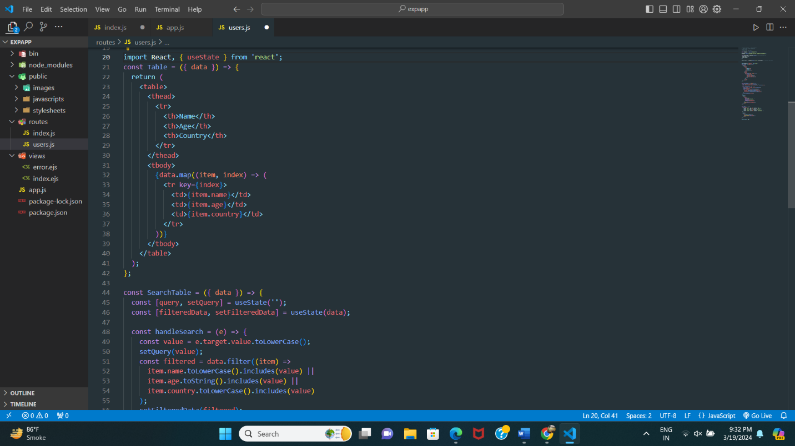

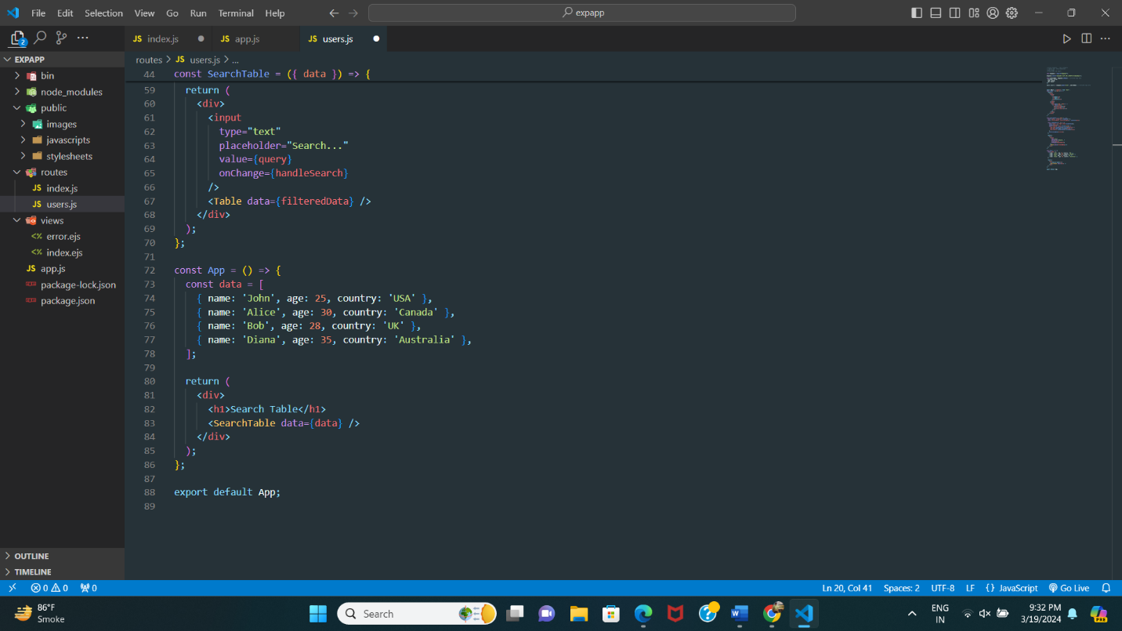

1. Create Login registration with CRUD Application using API (Redux)

